









ADAMAS

UNIVERSITY

ASSIGNMENT’S TOPIC
(FLOWCHART AND ALGORITHM)

NAME BIBHURANJAN PAUL

ROLL NO.:-SSUUG/04/BTCSE
UG/04/BTCSE/2025/089
REG NO. :-AU/2025/0000991

SUBJECT :-INTRODUCTION TO PROGRAMMING

SUBJECT CODE CSE11001
:
-

PROGRAM
:
-BTECH CSE (CORE)

SEC :-B

FLOWCHARTS
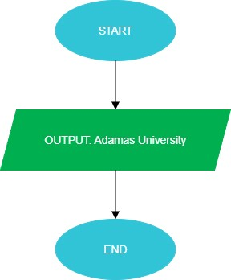
.

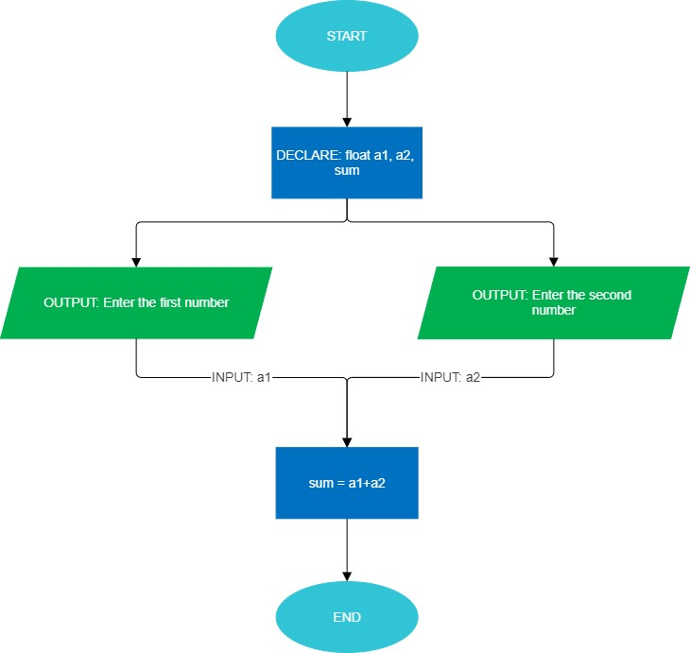

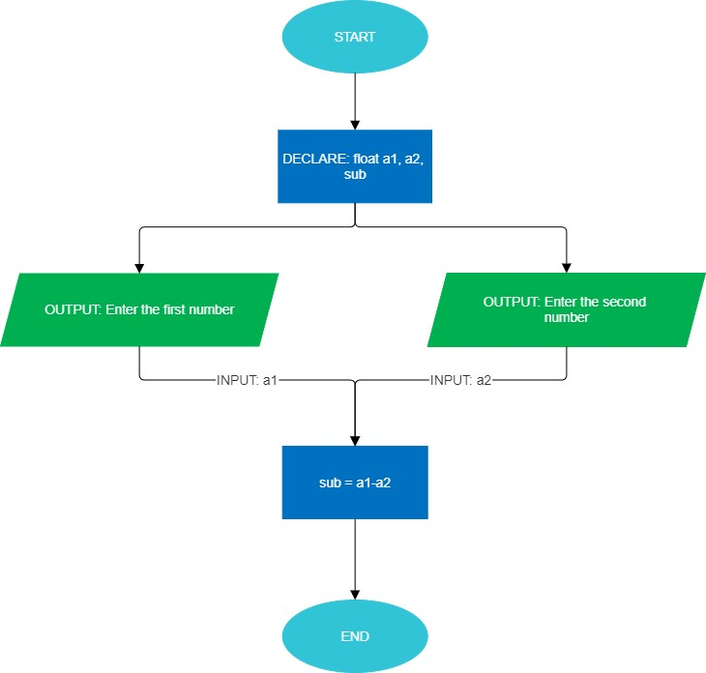

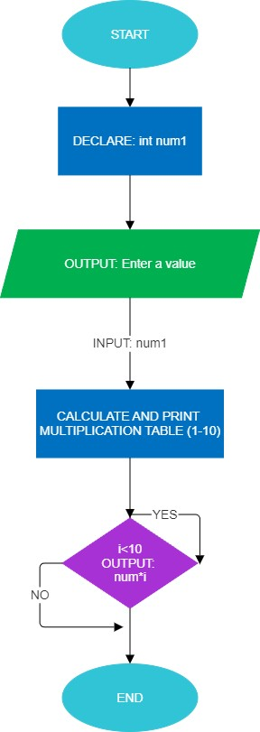

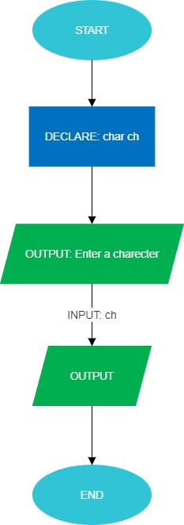

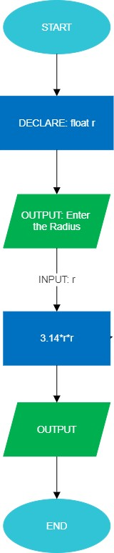

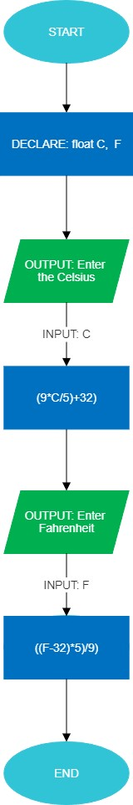
.

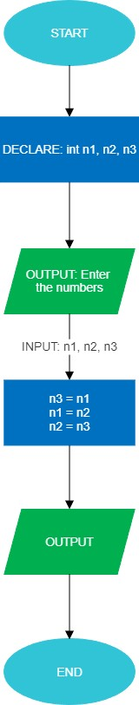
.
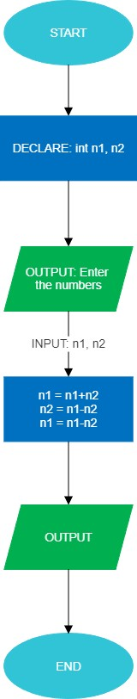
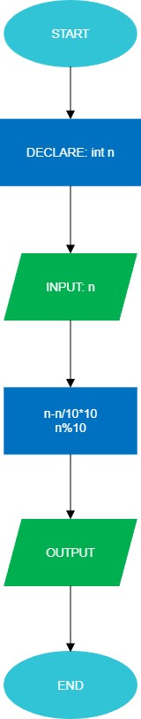
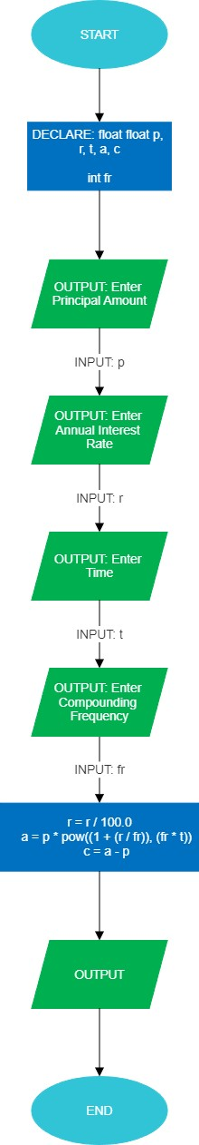
.
.

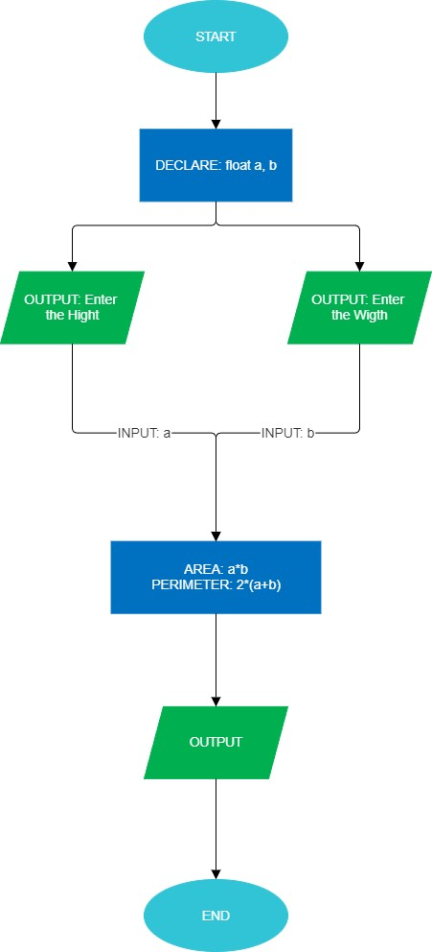

.

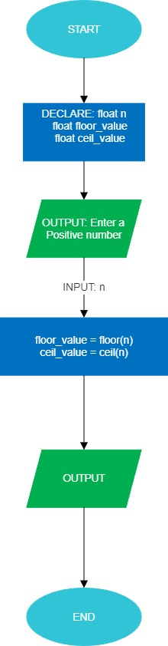

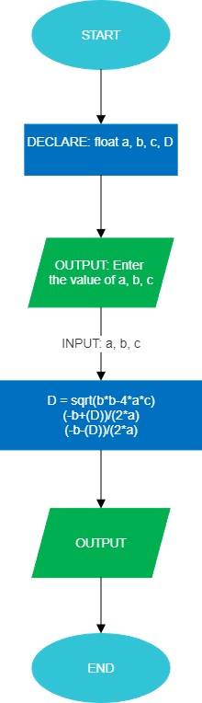
.

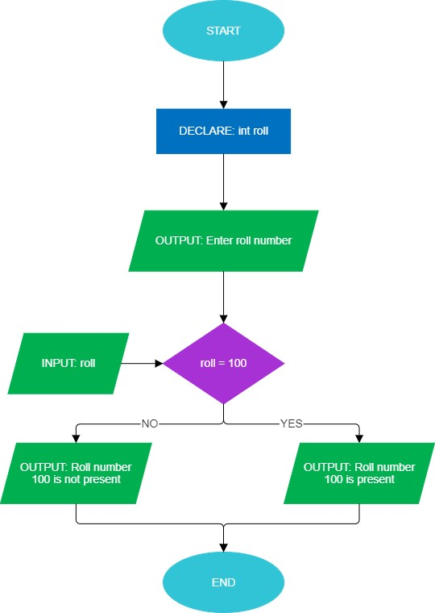

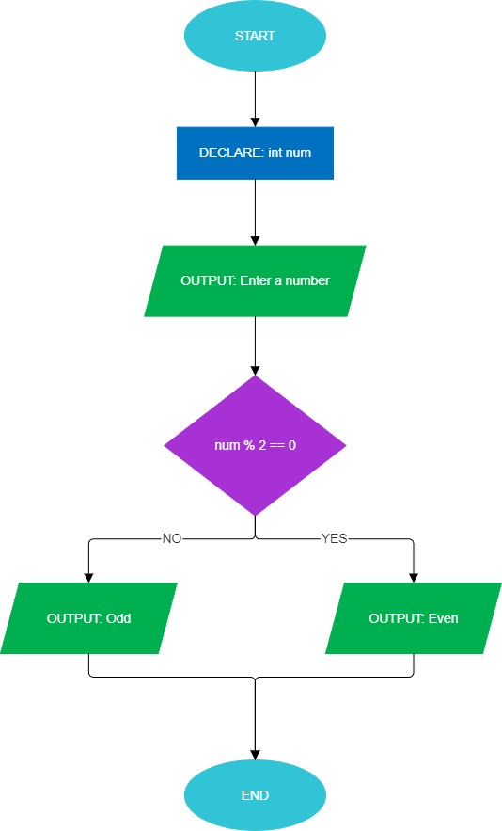
.

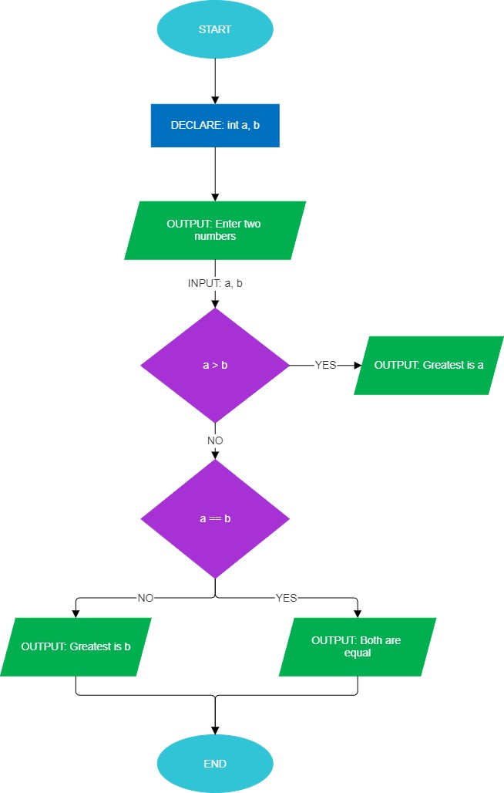

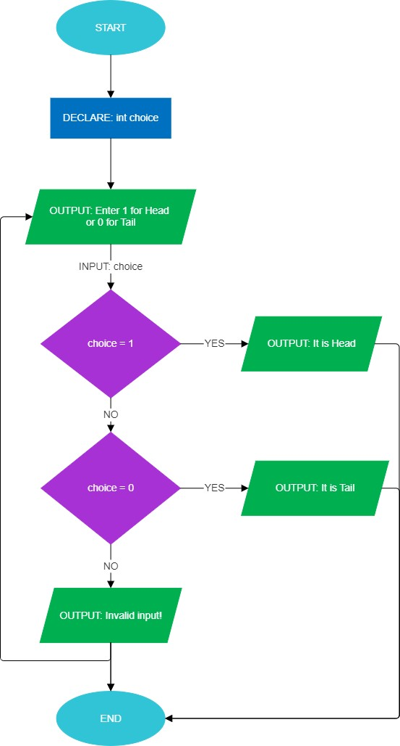
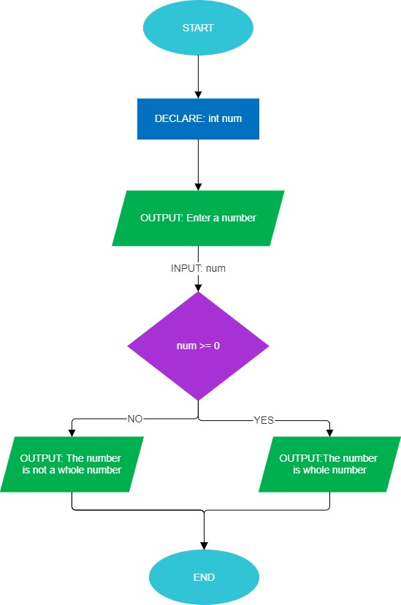

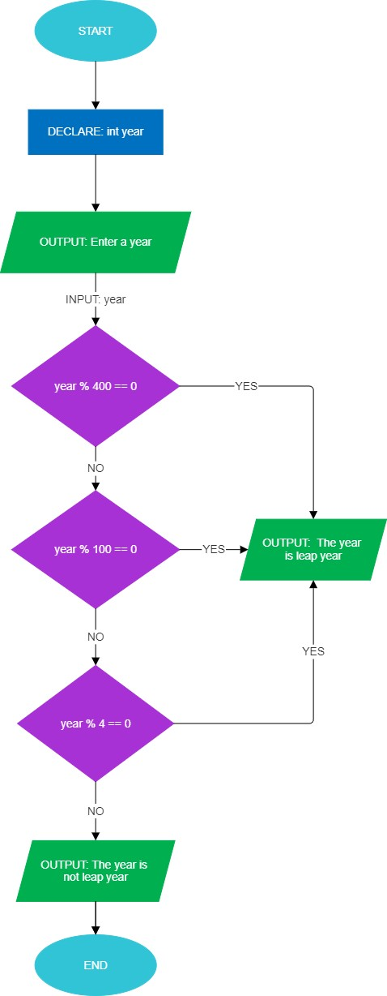
.

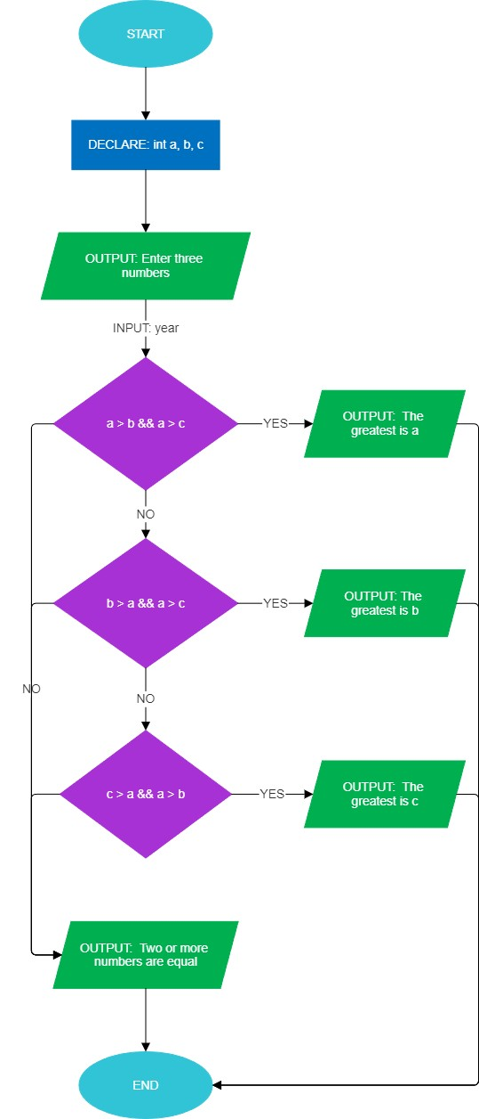
.

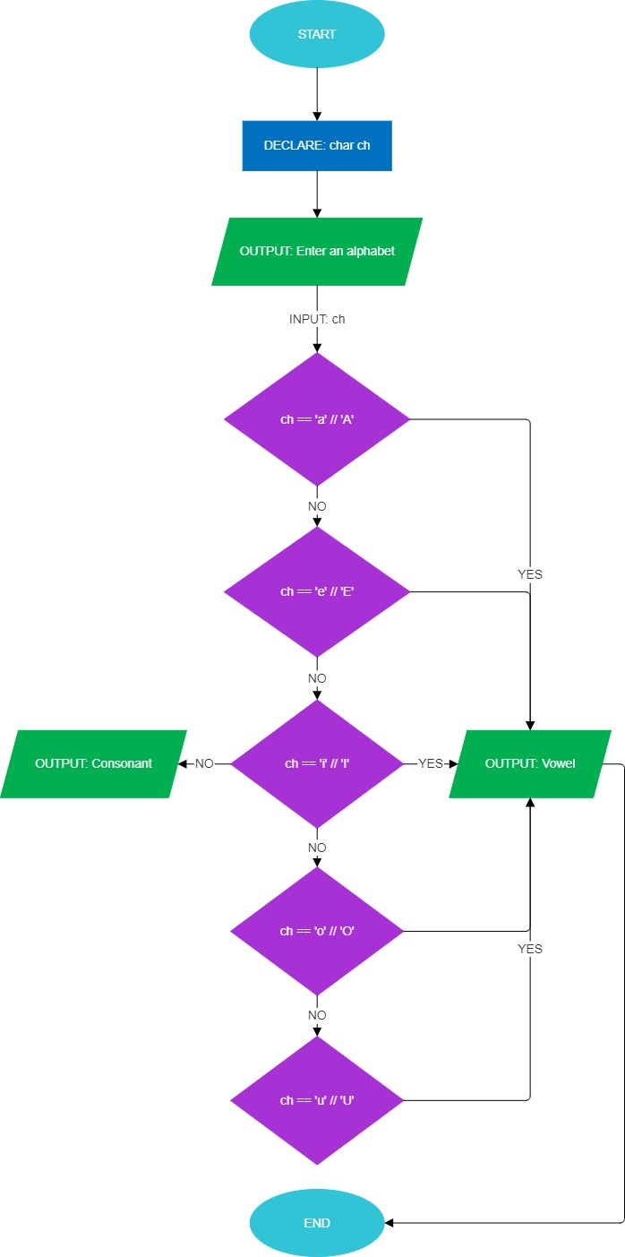
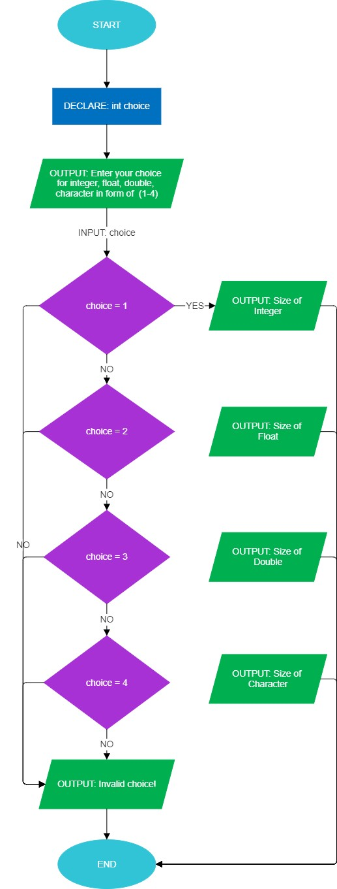
.

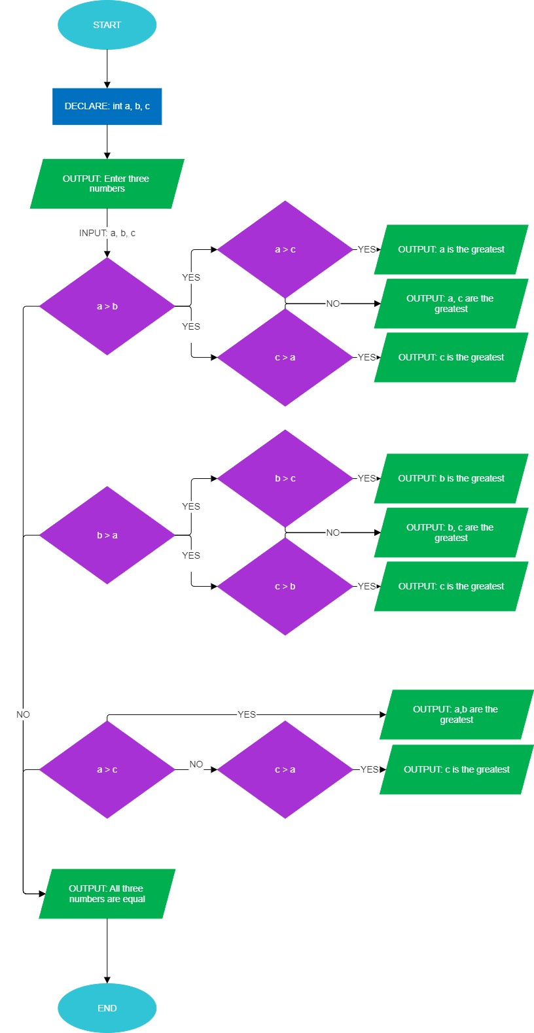
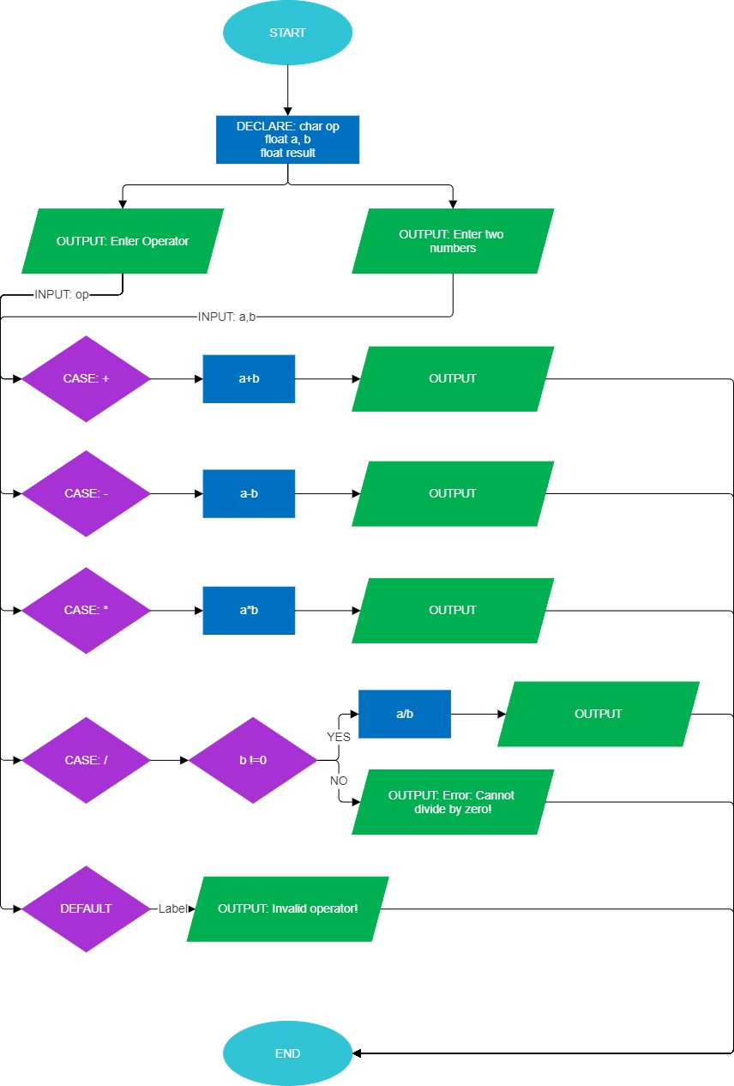

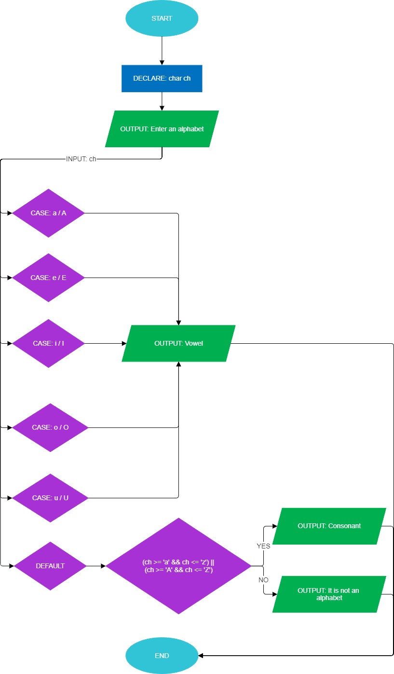

. 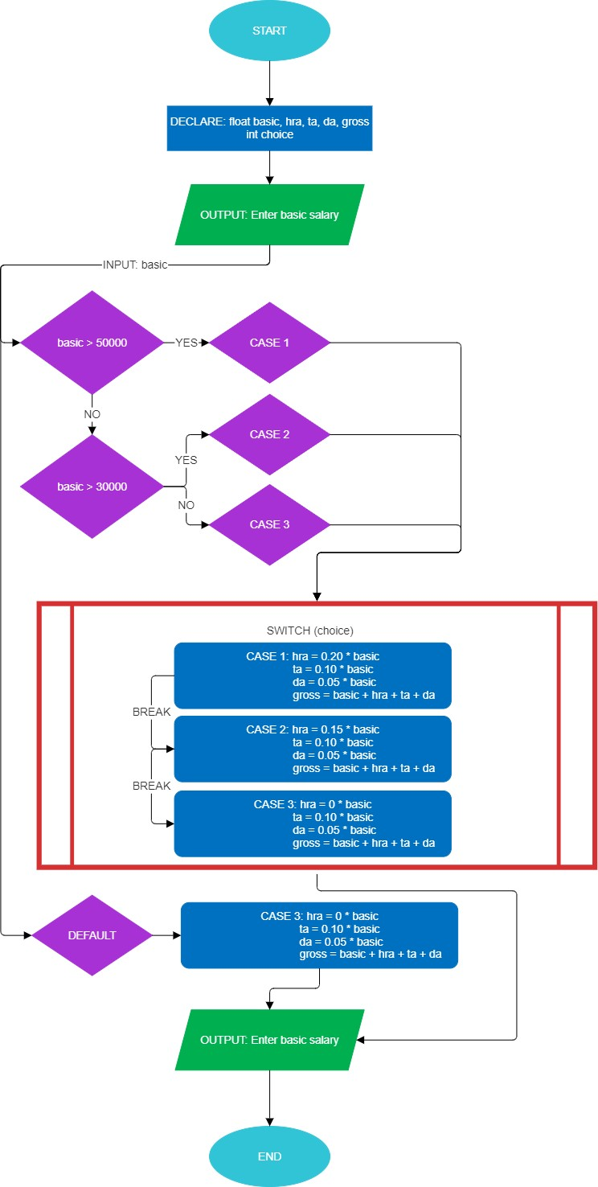
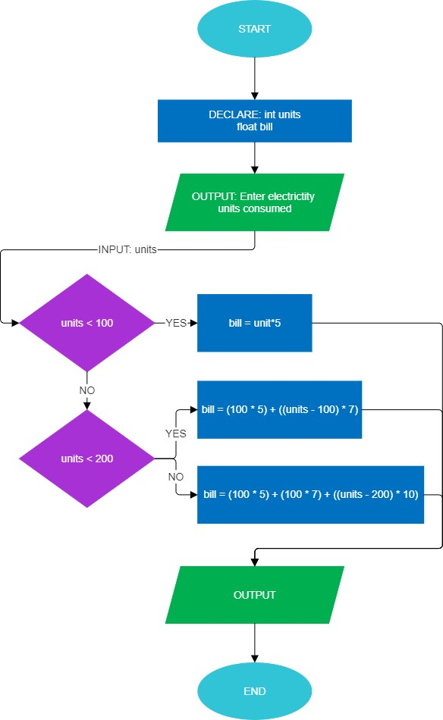
.

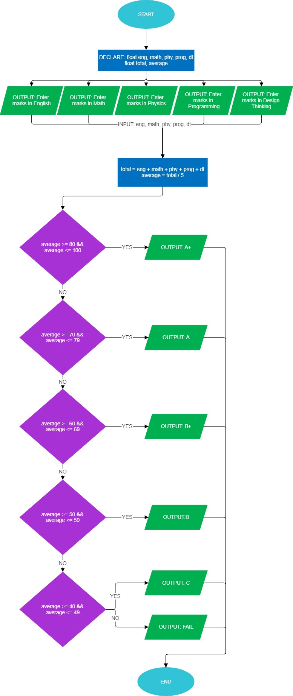

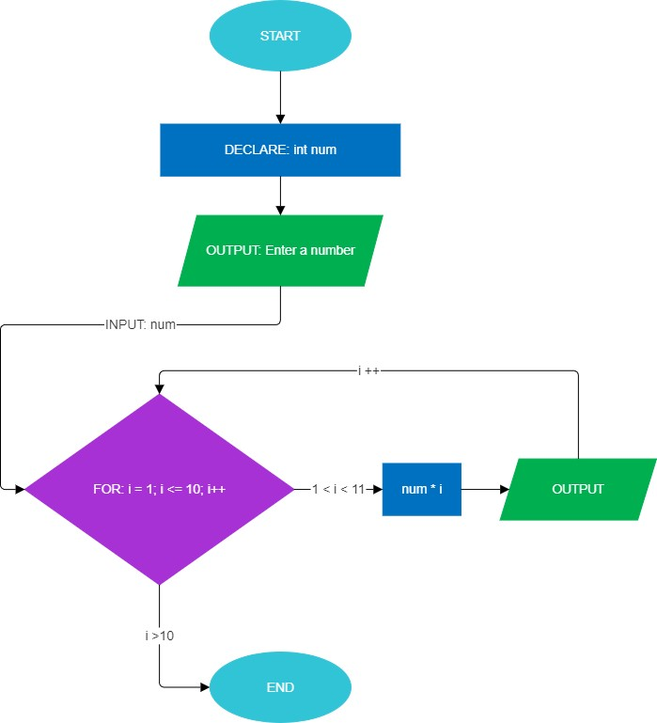
.

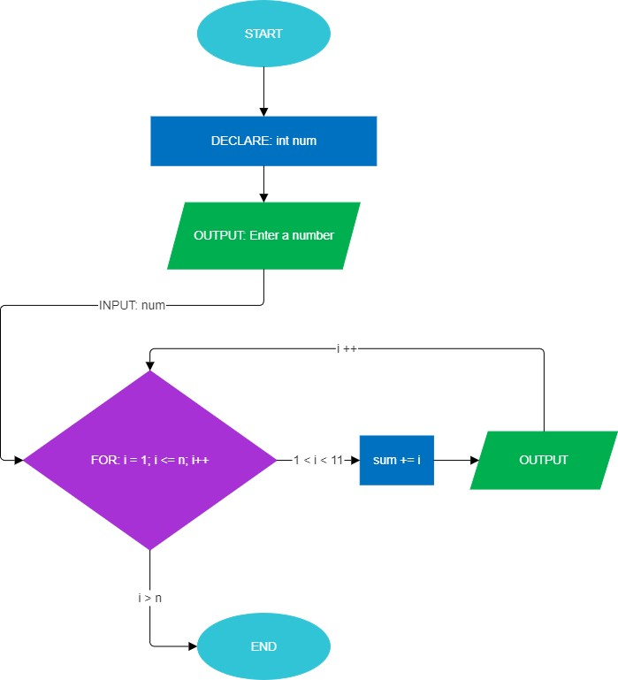

.

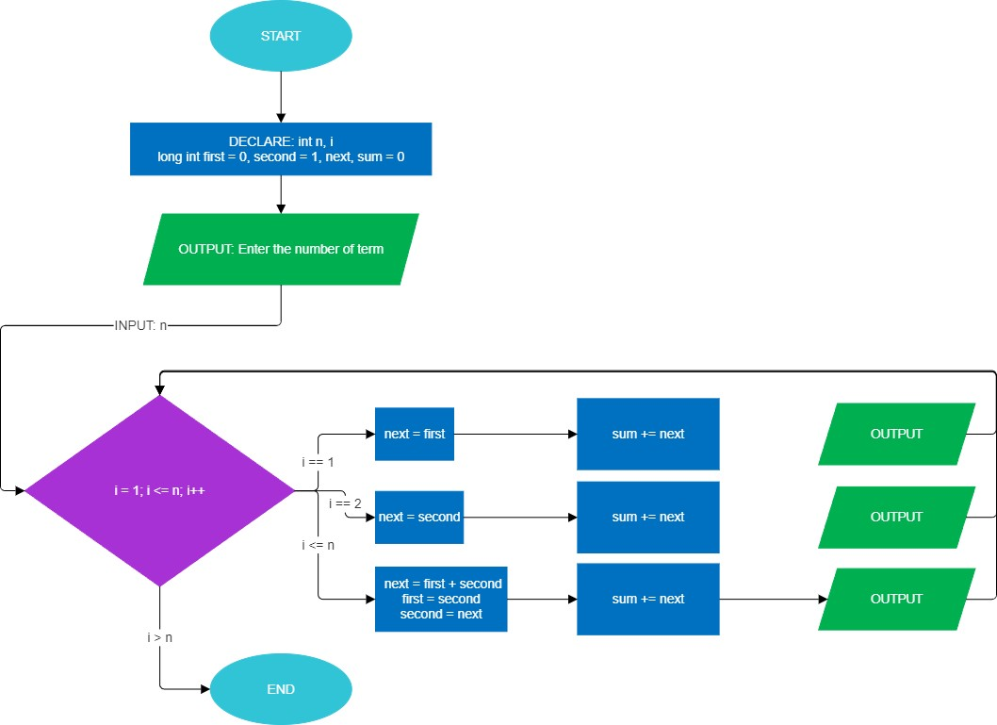

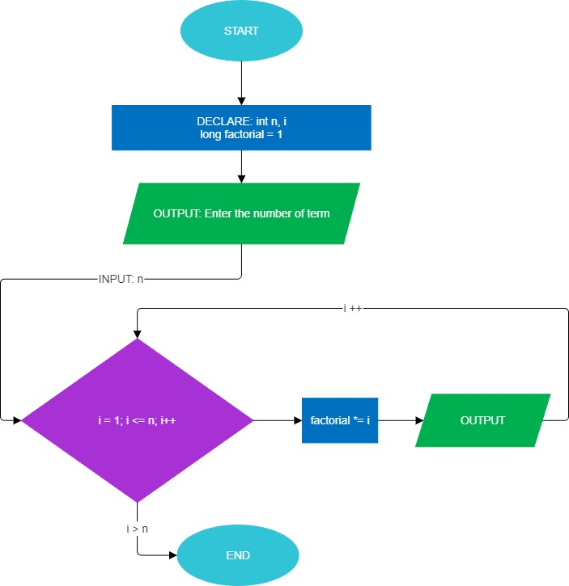
.
.

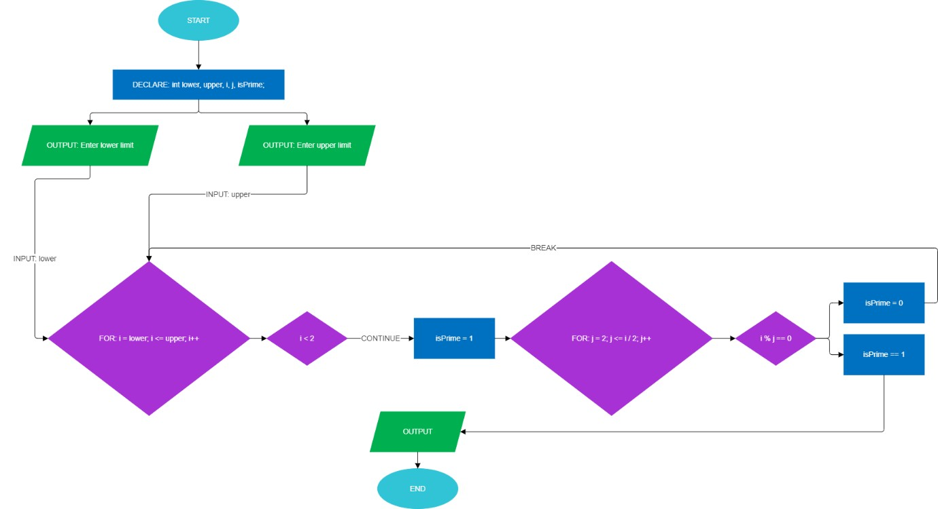

- WAP in C to print “Adamas University”.

Algorithm:

Start

Print "Adamas University" on the screen

Stop

- WAP in C to add two float numbers.

Algorithm:

Start

Input two float numbers (a, b)

Sum = a + b

Display the sum

Stop

- WAP in C to subtract two float numbers.

Algorithm:

Start

Input two float numbers (a, b)

Difference = a - b

Display the difference

Stop

- WAP in C to print multiplication table without using loop.

Algorithm:

Start

Input a number (n)

Use recursive function or direct print (1×n, 2×n … 10×n)

Display the table

Stop

- WAP in C to find ASCII value of a character.

Algorithm:

Start

Input a character (ch)

Convert ch to ASCII using (int)ch

Display ASCII value

Stop

- WAP in C to calculate Simple Interest (S.I.).

Algorithm:

Start

Input principal (P), rate (R), and time (T)

Calculate S.I. = (P × R × T) / 100

Display S.I.

Stop

- WAP in C to calculate the area of a circle.

Algorithm:

Start

Input radius (r)

Calculate Area = 3.14 × r × r

Display Area

Stop

- WAP in C to convert °F to °C and °C to °F.

Algorithm:

Start

Input choice (1 for °C→°F, 2 for °F→°C)

If choice = 1:
°F = (°C × 9/5) + 32

Else if choice = 2:
°C = (°F − 32) × 5/9

Display result

Stop

- WACP to swap 2 numbers using a 3rd variable.

Algorithm:

Start

Input a and b

Use temp = a

- = b

- = temp

Display new a, b

Stop

10) WACP to swap 2 numbers without using 3rd variable.

Algorithm:

Start

Input a and b

- = a + b

- = a - b

a = a - b

Display new a, b

Stop

11) WACP to find the last digit of an integer
- Using modulus operator)

Algorithm:

Start

Input number (n)

lastDigit = n % 10

Display lastDigit

Stop

- Without using modulus operator

Algorithm:

Start

Input number (n)

Divide n by 10 → Quotient = n / 10 Multiply Quotient × 10 → Subtract from n → lastDigit = n - (Quotient × 10)

Display lastDigit

Stop

12) WACP to calculate Compound Interest (C.I.).

Algorithm:

Start

Input Principal (P), Rate (R), Time (T)

Calculate Amount = P × (1 + R/100)^T

CI = Amount − P

Display CI

Stop

- WACP to find the area and perimeter of a rectangle.

Algorithm:

Start

Input length (l) and breadth (b)

Area = l × b

Perimeter = 2 × (l + b)

Display Area and Perimeter

Stop

- WACP to print the floor and ceiling value of a positive and negative number.

Algorithm:

Start

Input a number (x)

Use built-in floor(x) and ceil(x) functions

Display floor and ceiling values

Stop

- WACP to find the roots of a quadratic equation.

Algorithm:

Start

Input coefficients a, b, c

Calculate discriminant D = b² − 4ac

If D > 0 → roots are real & distinct r1 = (−b + √D) / (2a) r2 = (−b − √D) / (2a)
Else if D = 0 → roots are real & equal r1 = r2 = −b / (2a)

Else → roots are complex r1 = −b/(2a) + i√(−D)/(2a) r2 = −b/(2a) − i√(−D)/(2a)

Display roots

Stop

16)A coin has been tossed once WACP to check whether it's Head or Tail.

Algorithm:

Start

Generate a random number (0 or 1)

If number = 0 → print "Tail"

Else → print "Head"
Stop

17)WACP to check whether a number is positive or negative using a Ladder if else method.

Algorithm:

Start

Input number (n)

If n > 0 → print "Positive"

Else if n < 0 → print "Negative"

Else → print "Zero"

Stop

18) WACP to find the greatest among 3 numbers using Ladder if else method.
Algorithm:

Start

Input numbers a, b, c

If a > b and a > c → print a is greatest

Else if b > c → print b is greatest

Else → print c is greatest

Stop

19)WACP to check maximum among 3 numbers using nested if-else method.

Algorithm:

Start

Input numbers a, b, c

If a > b
If a > c → a is greatest
Else → c is greatest

Else
If b > c → b is greatest
Else → c is greatest

Display greatest number

Stop

20)WACP to check if a year is leap year or not.

Algorithm:

Start

Input year (y)

If y % 4 ≠ 0 → Not leap year

Else if y % 100 ≠ 0 → Leap year
Else if y % 400 = 0 → Leap year

Else → Not leap year

Stop

- WACP to check whether the Roll Number 100 is present or not using if loop only.

Algorithm:

Start

Input roll number (n)

If n = 100 → print "Roll number 100 is present"

Else → print "Roll number 100 is not present"

Stop

- WACP to check whether an integer is odd or even.

Algorithm:

Start

Input number (n)

If n % 2 = 0 → print "Even"

Else → print "Odd"

Stop

23)WACP to check the greatest among two numbers.

Algorithm:

Start

Input numbers a and b

If a > b → print "a is greatest"

Else → print "b is greatest"

Stop

24)WACP to check if a letter is vowel or consonant.

Algorithm:

Start

Input character ch

If ch = 'a' or 'e' or 'i' or 'o' or 'u' (or uppercase) → print "Vowel"

Else → print "Consonant"

Stop

25)WACP to find the size of integer, float, double and char.

Algorithm:

Start

Use sizeof() operator for int, float, double, char

Print the size of each data type

Stop

26) WACP to create a Simple Calculator using Switch-case.The Program should take number inputs as an operator (+, -, *, /) from the user and display the result.

Algorithm:

Start

Input two numbers (a, b) and operator (op: +, -, *, /)

Switch(op)
Case '+': result = a + b → break
Case '-': result = a - b → break
Case '*': result = a * b → break
Case '/': result = a / b → break
Default: print "Invalid operator"

Print result

Stop

27) WACP using Switch-case to check whether a given alphabet is a vowel or consonant.

Algorithm:

Start

Input character ch

Switch(ch)
Case 'a','e','i','o','u','A','E','I','O','U': print "Vowel" → break
Default: print "Consonant"

Stop

28)WACP that calculates the total salary of an employee using Switch-case.

Algorithm:

Start

Input basic salary and choice (for HRA, DA, TA, etc.)

Switch(choice)
Case 1: total = basic + HRA
Case 2: total = basic + DA
Case 3: total = basic + TA
Default: print "Invalid choice"

Print total salary

Stop

29) WACP using Switch-case to calculate the electricity bill based on units consumed.

Algorithm:

Start

Input units consumed (u)

Switch(unit slab)
Case 0–100: bill = u * 5 → break
Case 101–200: bill = u * 7 → break
Case 201–300: bill = u * 10 → break
Default: bill = u * 15

Print bill

Stop

30)WACP using switch-case to display the grade of a student based on their marks.

Algorithm:

Start

Input marks (m)
Calculate grade slab = marks/10

Switch(grade slab)
Case 10, 9 → print "A+"
Case 8 → print "A"
Case 7 → print "B"
Case 6 → print "C"
Default → print "Fail"

Stop

- WACP to find sum of n natural numbers.

Algorithm:

Start

Input n

Initialize sum = 0

For i = 1 to n → sum = sum + i
Print sum

Stop

- WACP to print a multiplication table using for loop.

Algorithm:

Start

Input number (n)

For i = 1 to 10 → print n × i

Stop

- WACP to print factorial of a number using for loop.

Algorithm:
Start

Input number (n)

Initialize fact = 1

For i = 1 to n → fact = fact × i

Print fact

Stop

- WACP to print Fibonacci series up to n terms.

Algorithm:

Start

Input n (number of terms)

Initialize a=0, b=1

Print a, b

For i = 3 to n → c = a + b → print c → a=b, b=c

Stop

- WACP to print all prime numbers between a certain range using for loop.

Algorithm:

Start

Input lower limit (l) and upper limit (u)

For num = l to u
Initialize flag=0
For i = 2 to num/2 → if num%i==0 → flag=1 → break
If flag==0 → print num (prime)

Stop

